STANDARD OPERATING PROCEDURES FOR SAMPLED-BASED AREA ESTIMATION
Purpose: These Standard Operating Procedures (SPO) Notes acts as a set of general Cheat-sheets, which in conjunction with a more general posterior white paper, aim to be the main support backbone documents for national staff working in area reporting for REDD+. The SPO will be modified to fit the particular protocols of each country and ensure that they are repeatable.
Important Notes for Completing this Document
Under most headings in this template are instructions for completing each section; they are marked in this way: << instructions for completing the section >>. Please read through the instructions for details on minimum requirements.

Important note: No sections are to be deleted from this document.

Text contained within << >> provides information on how to complete that section and can be deleted once the section has been completed.
Table of Contents
Standard Operating Procedure 1 (Sop1): Spatially Referenced Sample Designs For Area Estimation 3
Section 1 Overview 3
Section 2 Procedure 3
Section 3 Quality management 6

Standard Operating Procedure 1 (Sop1): Spatially Referenced Sample Designs For Area Estimation

Section 1 Overview
Purpose | Establish a spatially-referenced, probability-based and geographically balanced sampling design for the estimation of areas in land surveys.
Scope | The reporting requirements will identify the sampling and target populations.
Responsibilities | Remote-sensing/GIS and statistics technical officers, as well as policy- and decision makers in REDD+ countries and international agencies, multilateral and bilateral programmes, in particular for the estimation of activity data (i.e., land use/land cover change) for emissions/removals in REDD+ activities.
Prerequisites | - Project objectives  - Land and/or land use change definitions  - Region or area of interest defined  - Response design, aligned with land/land use change definitions  - Map production (SOP0)
Requirements | - Spatially explicit representation (i.e., satellite imagery) of land or else geospatially referenced field ground data  - Maximum allowable error (d), given as an area fraction, $E ∈(0,1)$. This is the maximum half-width of the confidence interval we aim towards in our estimate.  - Confidence level for the estimation of uncertainties  - Access to the FNDS mapping interfaces on the Google Earth Engine Cloud Computing Platform.

Section 2 Procedure
Sampling designs and sampling units | Sampling units  The sampling unit is centered on the 20m pixel. See response design (SOP2) for more details. All pixels are derived from an annual deforestation map and classified as stable forest, stable non-forest, or one of several deforestation probability classes. Map classes are as follows:  Label Class  High probability deforestation 1  Buffer deforestation 2  Low probability deforestation 3  Stable forest 4  Stable non-forest 5  (Post-stratified deforestation) 6  Classes 1-5 will always be present, whereas class 6 is specific to the case where post-stratification has been performed to improve map quality due to the omission of deforestation events. See Map production – SOP0 for more details.  Sampling design  According to Olofsson et al. (2014) and FAO (2016), stratiﬁcation is recommended to ensure a sufficient representation of rare classes (e.g. that only represent a small proportion of the area of interest – forest loss) and improve the precision of the accuracy and area estimates by increasing the sampling density in the change classes. For this reason, the sampling design is Stratified Random Sampling (STR), with the strata taken from the annual deforestation map (see Map production – SOP0). Sample points should be centered on map pixels and all have unique locations (i.e. no double-counting).  The sampling design is performed in the FNDS mapping interfaces, specifically the section "Stratified Sampling", as shown in Figure 1. This section was designed to apply a fixed number of samples defined by the user for each map class. For generating samples, the operator should:  - Run the script provided by the section;  - Load the boundary polygon for the area of interest on the "Province" menu;  - Load the annual deforestation map on the "Classified image" menu;  - Set the desired number of samples on the "Samples per class" menu;  - Display the samples by clicking on the button "DISPLAY"; and  - Export the generated samples in "CSV format" by clicking on the button "EXPORT POINTS TO DRIVE".  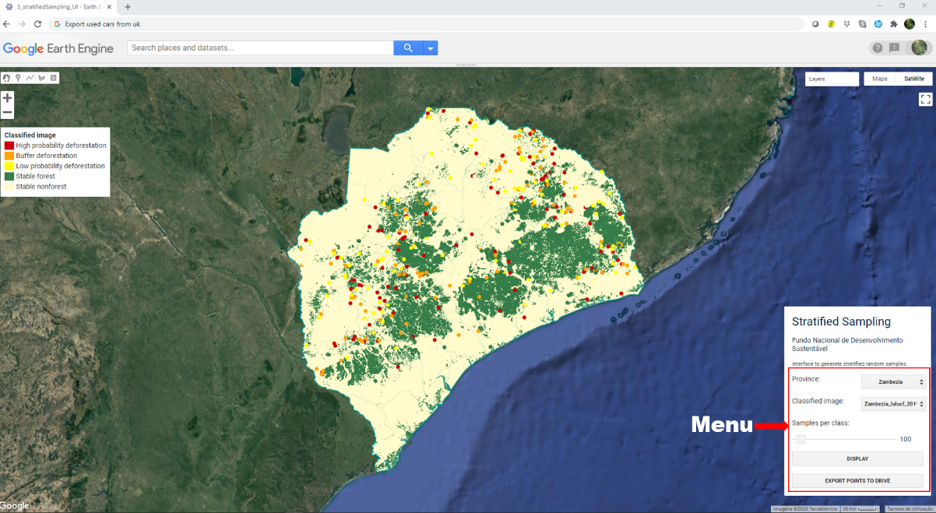  Figure 1 The section "Stratified Sampling" from the FNDS mapping interfaces on the Google Earth Engine Cloud Computing Platform, for stratified sampling of deforestation map.
Estimating sampling size | The sample size n is determined from the equation (Cochran, 1977):  $$n=\frac{{\left(\sum{W_{i}S_{i}}\right)}^{2}}{{\left[S(\hat{O})\right]}^{2}+(\frac{1}{N})\sum{W_{i}S_{i}}}≈{\left(\frac{\sum{W_{i}S_{i}}}{S(\hat{O})}\right)}^{2}$$ Equation 1  Where:  N is the number of units in the region of interest,  S(Ô) is the standard error of the estimated overall accuracy that we would like to achieve,  W_{i} is the mapped proportion of area of class i; and  S_{i} is the standard deviation of stratum i.  In order to obtain approximate values of proportion of deforestation in each stratum (p_{i}), a pilot sampling is conducted. According to Congalton and Green (2008) and Olofsson et al (2014), the minimum sample size should be at the least 20 to 100 samples per stratum. For this reason, the pilot sampling uses 100 sample points for each map stratum.  After the pilot sampling, samples need to be added to each stratum, in order to reach the desired relative error. It was decided to use the Optimum (Neyman) allocation (Neyman, 1934), where the stratum standard deviation $S_{h}=\sqrt{U_{h}∙(1-U_{h})}$ increases the number of plots (ensuring larger numbers of plots in rare classes or strata) and sampling unit costs are constant:  $$n_{h}=n\frac{w_{h}∙S_{h}}{\sum_{h=1}^{H}{w_{h}∙S_{h}}}$$ Equation 2  There should be a minimum of 300 sample units in each of the stable classes. The reason behind this minimum is that if no deforestation events are found in the 100 sample units of each stable stratum, then p_{i} will be 0, and we would require no further sampling of these strata. This would mean that the sample size for the stable strata would be much smaller than for the change strata, even though the stable classes make up the majority of map area.

Section 3 Quality management
Sampling designs and sampling units | Each sample unit should have a unique location, without repeat-measurements at the same location. It should be checked that no sample units overlap between the pilot sampling phase and adding of new strata. This can be ensured by generating a large number of random sample points at the outside (~1000 per class) and drawing new sample units from these.  The same procedure also should be ensured in the initial sampling so that there is no a replacement of a sample from the pilot sampling with adding additional samples (if necessary), once the additional samples will be extracted from the same source.
Sampling size | The initial sampling size is 100 for all strata, in order to have a first estimate of proportion of deforestation in each stratum. This allows the determination of total sample size required for desired error.  Sample size for stable classes, in the case of no omission errors of deforestation, is set to a minimum of 300. This is to reduce the probability of not finding omission errors “by chance”.
Data Flow Diagram | 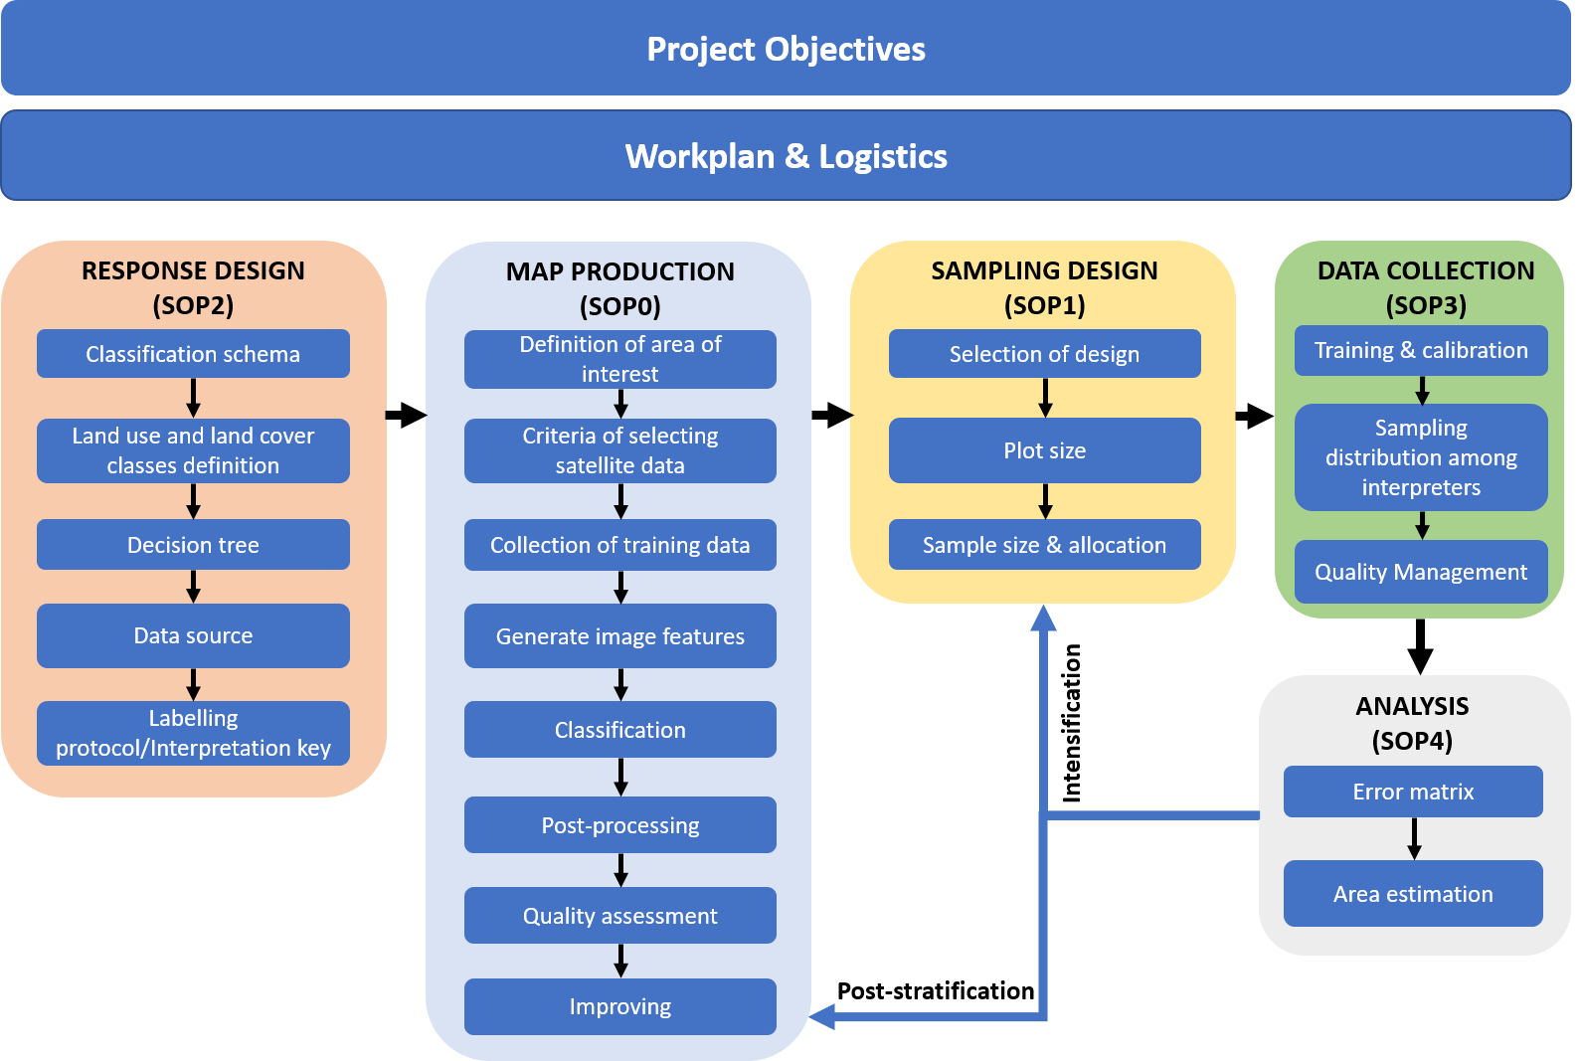
References | Cochran, W. G. 1977. Sampling techniques. John Wiley & Sons.  Congalton, R. G. & Green, K. 2008. Assessing the Accuracy of Remotely Sensed Data: Principles and Practices, Second Edition. CRC Press  FAO. 2016. Map Accuracy Assessment and Area Estimation: A Practical Guide. National forest monitoring assessment working paper No.46/E, 60p.  Neyman, J. 1934. On the Two Different Aspects of the Representative Method: The Method of Stratified Sampling and the Method of Purposive Selection. Journal of the Royal Statistical Society, Vol. 97, 558-606.  Olofsson, P., Foody, G. M., Herold, M., Stehman, S. V., Woodcock, C. E., Wulder, M. A. 2014. Good practices for estimating area and assessing accuracy of land change. Remote Sensing of Environment, 148:42–57.

© 2021 by MRV Unit under the Fundo Nacional do Desenvolvimento Sustentável. Standard Operating Procedures for Sampled-Based Area Estimation is made available under a Creative Commons By 3.0 IGO license: https://creativecommons.org/license/by/3.0/igo/
For more information, please visit:
- Mozambique MRV website: https://www.fnds.gov.mz/mrv/

Please cite as: Unidade de MRV-FNDS. 2020. Standard Operating Procedures for Sampled-Based Area Estimation: Spatially Referenced Sample Designs. Fundo Nacional do Desenvolvimento Sustentável (FNDS), Maputo, Mozambique.

